Steps to query Stack Overflow data from BigQuery and Jupyter Notebook

1. Login/Create an account on Google Cloud. Search for BigQuery API and enable it from the console.

<https://cloud.google.com/>

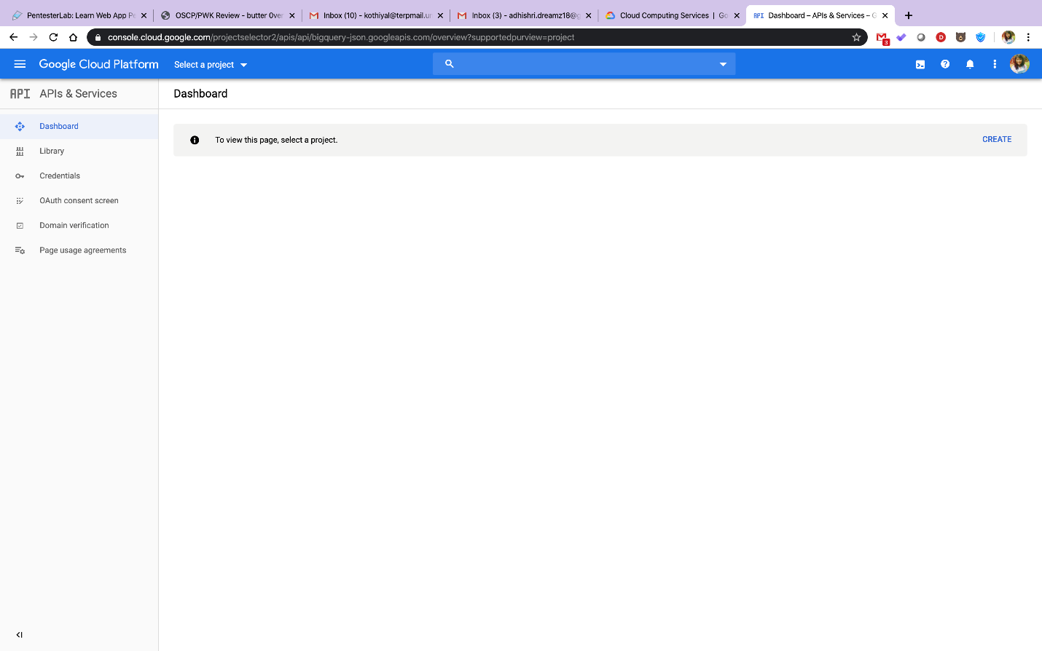

1. Create a project and give it a suitable name. For eg: Python Project.

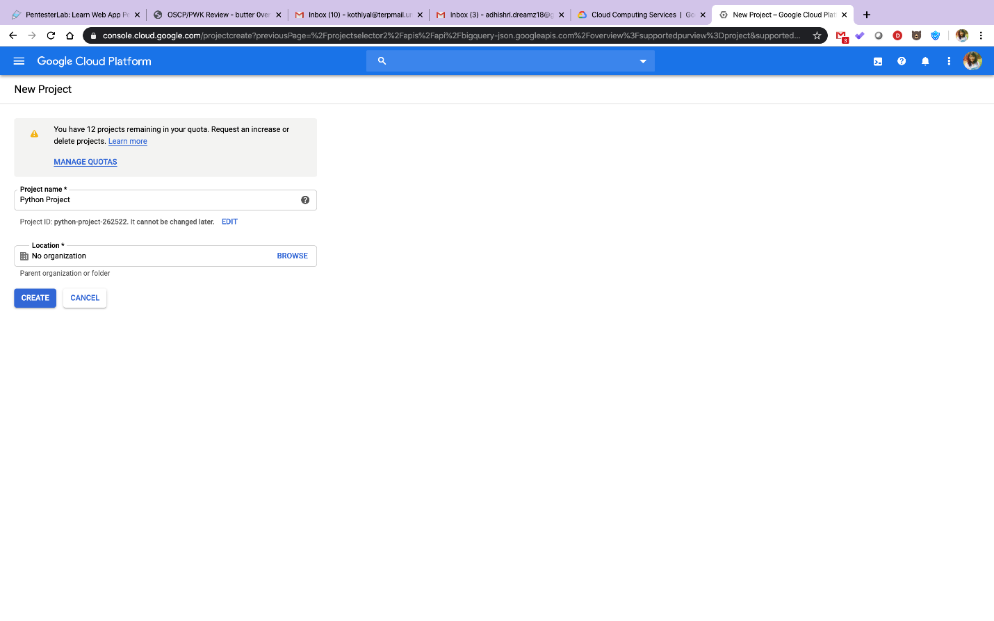

1. 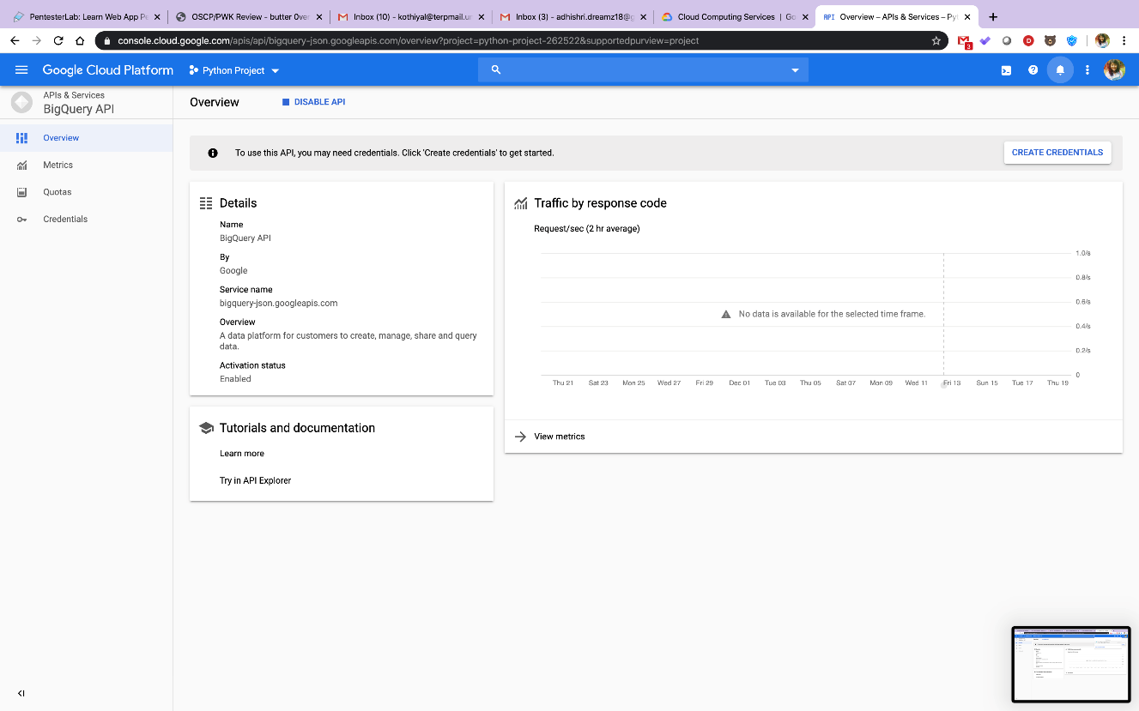Next, go to credentials and create service account key.

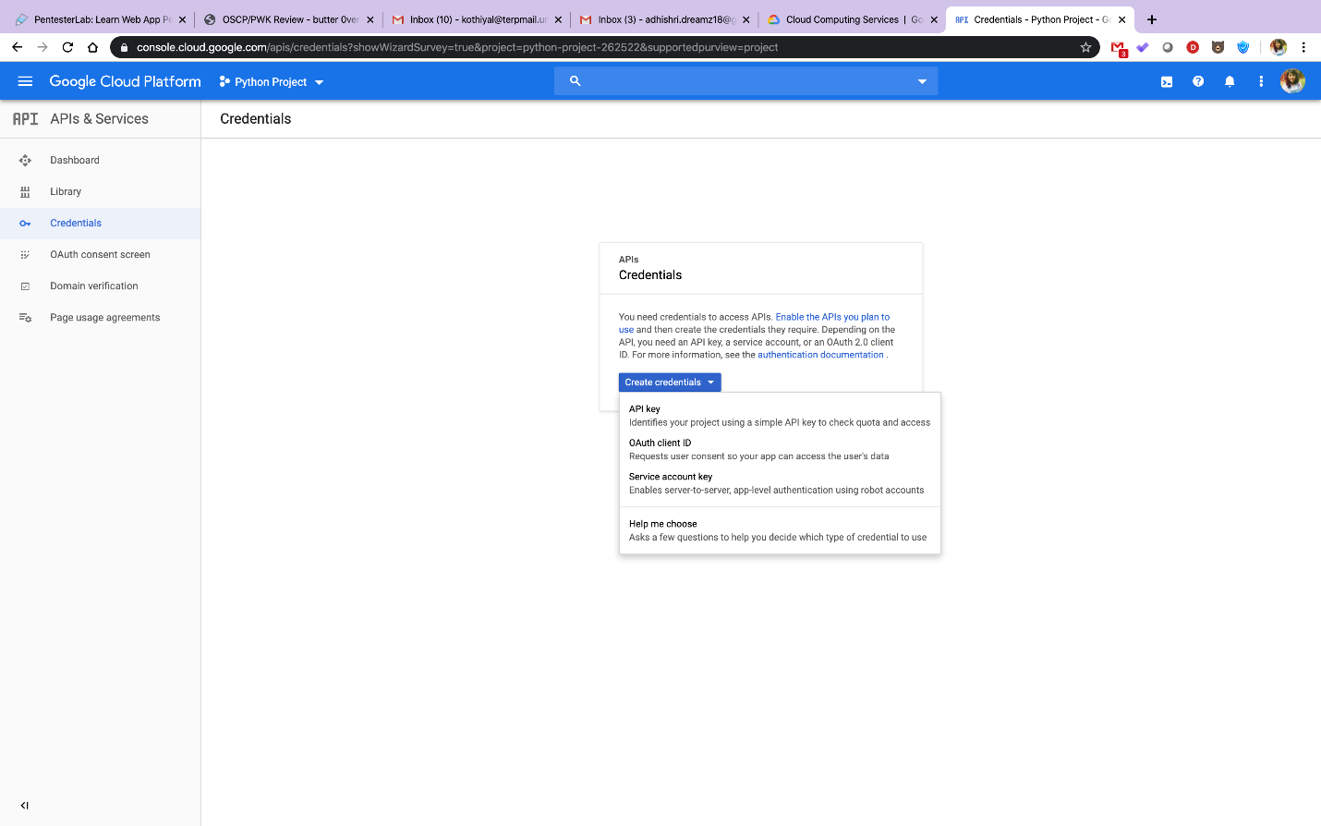

1. 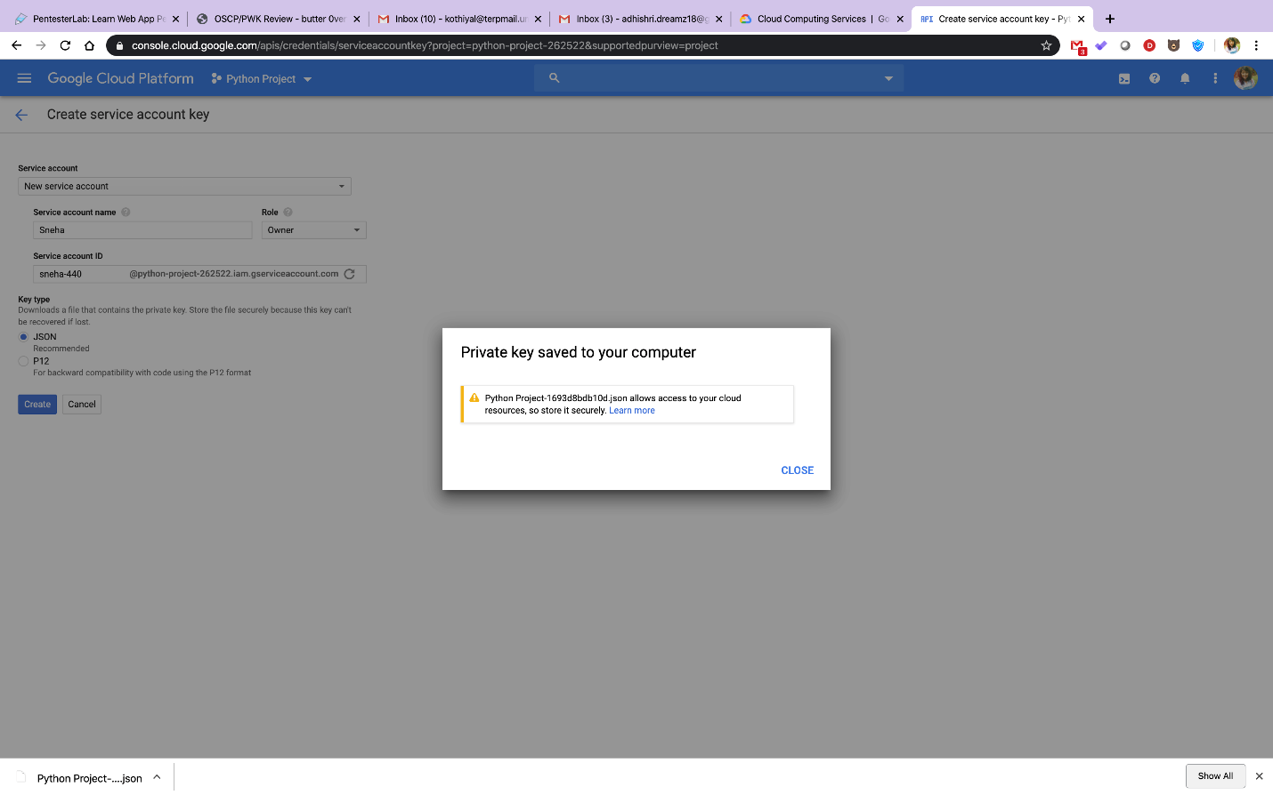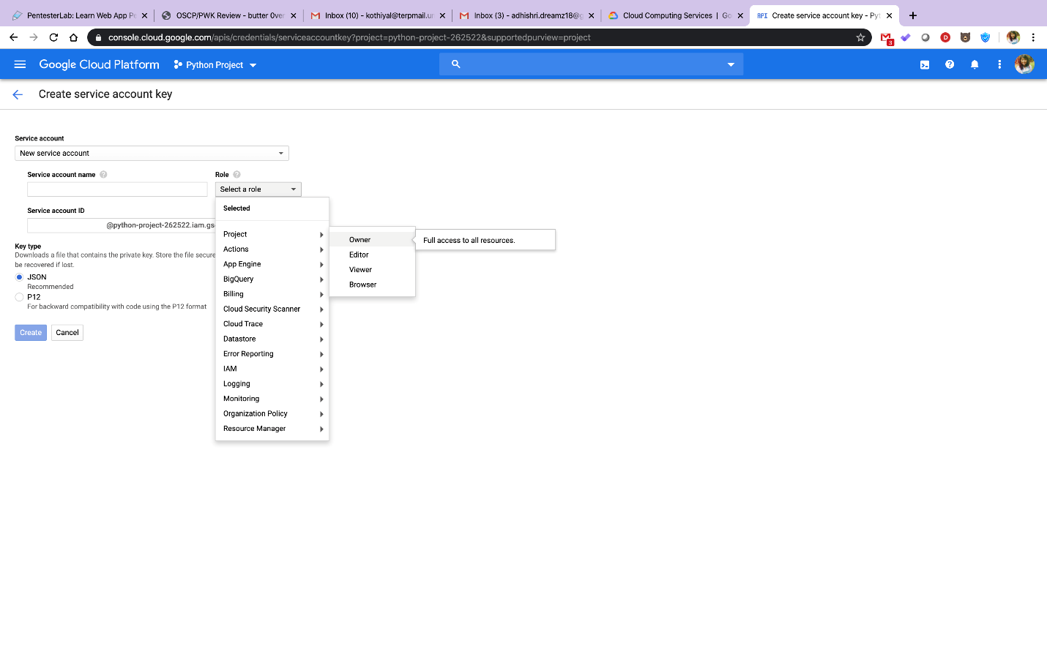Select ‘new service account’, give it a suitable name. In role select Project > Owner (this gives you the full admin access). Select json and click create. This will download a .json file on your computer. Save it in any suitable folder and copy its path to clipboard.
2. We can now head over to our Jupyter notebook.

Execute the following command in your notebook: pip install google-cloud-bigquery

Locate the below code in the notebook and remove path of our json file and replace it with the path of the json file that you copied to clipboard.

import os

os.environ['GOOGLE_APPLICATION_CREDENTIALS'] ='<paste the path of the .json file that you copied to clipboard'>